## Merchant

Scoping start date: May 9, 2024

MSA Signature Date: May 31, 2024  
Onboarding Kick Off Date: Jun 3, 2024  
Go Live Date: Jun 30, 2024

GTM POC: Nick  
Implementation POC: Ariel and Royce

ERP: Other Campfire

Tax Integration: No Tax Moving to Anrok soon

### 

### Key people at Merchant

### ~~CFO: KP Peters~~

### Customer service rep who is really involved: Yossi Vaknin

### VP of CS who will be in charge of onboarding

* Finance: **Erik Leavell**

### Company summary

April is a series A tax platform that simplifies the filing process for U.S. taxpayers and enables better financial planning. They are planning a raise in the next year and needed a better way to cash forecast. ~~Their COO (KP) currently runs their finances and didn’t want to hire a CFO yet.~~ They chose Tabs because they have a very complex AR process with remittances and wanted to be attractive to top talent finance leaders.

### Billing model

* Work with banks as an embedded tax solution for their clients. The remit to the banks based on # of users that sign up with April
* How a contract is broken up: Bill annually right after tax season. Some monthly billing
* Are there unique things about the customer creation process for this merchant?
  + Unsupported GL - Customers should be created as part of the contract processing process.

### Contract Processing Steps

**When a contract is done processing, please send Slackbot for the first invoice.**

**Steps to process**

1. Identify customer name, create a customer
2. Assumptions
   1. Contract duration is one year if not listed
   2. Use the today date if there’s no service start date
3. Identify the Product and offerings
   1. Implementation fee [use product category **Implementation**]
      * 1. This is sometimes waived
        2. Date should be Effective Date
   2. Flat fee annual minimum spend [use product category **Minimums**]
      * 1. Minimum annual - this is usually billed up front, but there is sometimes a monthly option listed. Process as upfront by default and ignore monthly option unless we get other info from the merchant - slack @ashni in case you see the monthly option
        2. Date should be Effective Date
        3. Minimum is sometimes waived for the first year or two
           1. If this is the case, please process at $0
           2. If waived for another year within the service term before auto-renewal, then this would be a recurring BT for however many years it is waived
   3. Flat fee platform [use product category **Platform**]
   4. Usage (could be multiple usage line items) [use product category **Usage**]
      * 1. Tax Filing
           1. Unit price
           2. Monthly billing on 1st of the month, starting the month after the contract is signed
           3. Event type: Tax Filer
        2. Estimator/Optimizer
           1. Unit price
           2. Monthly billing on 1st of the month, starting the month after the contract is signed
           3. Event type: Tax Estimation
        3. For either of the above types of usage BTs, sometimes there is a specific number listed that shows the monthly minimum. If this is listed, ignore and still process as a monthly usage (example below)  
           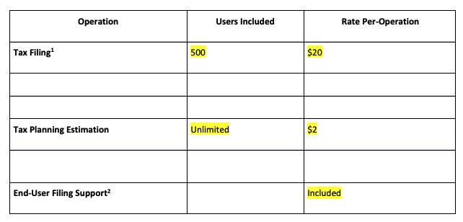
        4. Tier usage based
           1. Monthly billing on 1st of the month, starting the month after the contract is signed
4. If $0 terms are listed, **still process.**
5. Net Terms: Payment term is specified in the contract
   1. Auto-renewal
      1. Terms are specified in the contract, but do not process. **Only process initial term**

**\*\*\*When a contract is processed, send Slack bot notification for the first invoice**